

|  |
| --- |
|  |

|  |
| --- |
|  |
| UEFA Ranking System |
| Mobile Android App User Manual |

Contents

Preface 2

About This Manual 2

Audience 3

Overview of Application 4

Installing UEFA Ranking App 5

Opening the App for first use 6

Main Menu 7

Qualifying Rounds Menu 8

1st Qualifying Round 9

2nd Qualifying Round 10

3rd Qualifying Round Section 12

3rd Qualifying Round – Champions Route 13

3rd Qualifying Round – League Route 15

4th Qualifying Round – League Route 17

Group Stages 19

Team Ranking Section 21

Country Ranking Section 23

Additional Sections 25

About Section 25

Help Section 25

Troubleshooting 26

# Preface

## About This Manual

The User Manual provided contains information about the functionality and services available with the UEFA Ranking System Mobile Android Application (which will be referred to as ‘the app’ throughout the document).

## Audience

The Android App has been developed in conjunction with the UEFA Ranking System. The app is intended for those who want to use their Android Device to access elements of the Ranking System.

The app aims to tend to the needs of Football Clubs, Football Organizations (FAI, UEFA), and Statistical Reviewers. To a lesser extend it has also been designed and implemented for anyone with a remote interest in the Champions League and UEFA Rankings.

# Overview of Application

The UEFA Ranking App is a complete replication of the UEFA Ranking System and contains various elements that are of use to anyone with an interest in the Ranking System itself.

The App contains the following sections

* Main Menu
* Champions League Qualifying Rounds
* Champions League Group Stage
* UEFA Team Rankings
* UEFA Country Rankings
* Help Section
* About Section

## Installing UEFA Ranking App

The application can be installed by opening the APK file for the version you have downloaded from the respective site.

**Note: The App requires Internet Access to run all functionality.**

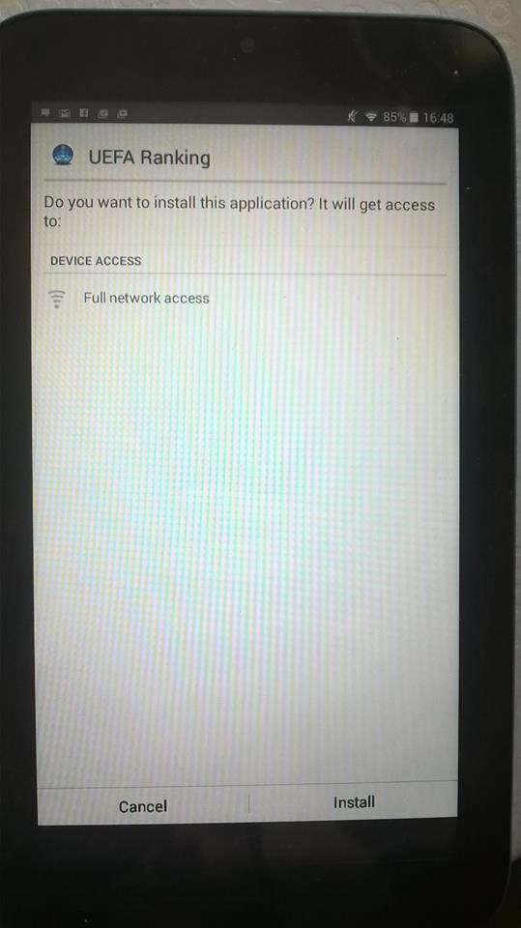

## Opening the App for first use

To launch the app, tap the application icon on the Application screen of the Android Device you are using.

Please ensure you have WIFI or a Mobile Connection before opening the Application.

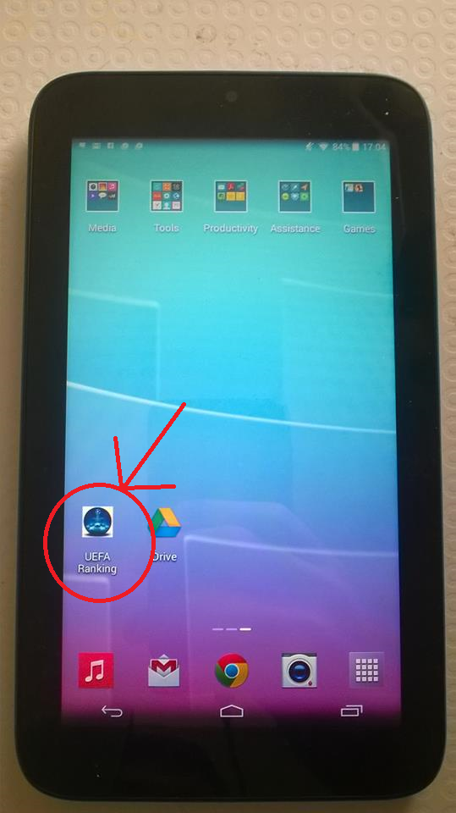

## Main Menu

After opening the app and being greeted with a Title Screen you will be brought to the ‘Home’/Main Menu Screen.

The Menu contains Navigation options to all sections of the App.

Simply tap on any section to enter.

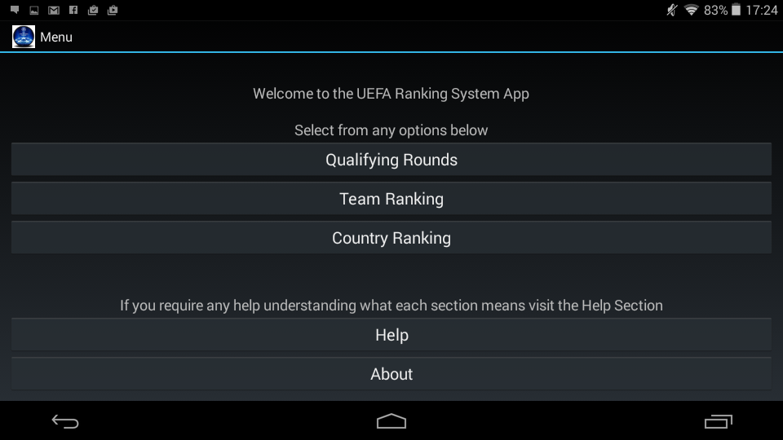

## Qualifying Rounds Menu

After selecting the Qualifying Rounds Option in the menu you will be greeted with various Qualifying Rounds and the Champions League Group Stage.

Each Round and the Group Stage can be accessed through this menu.

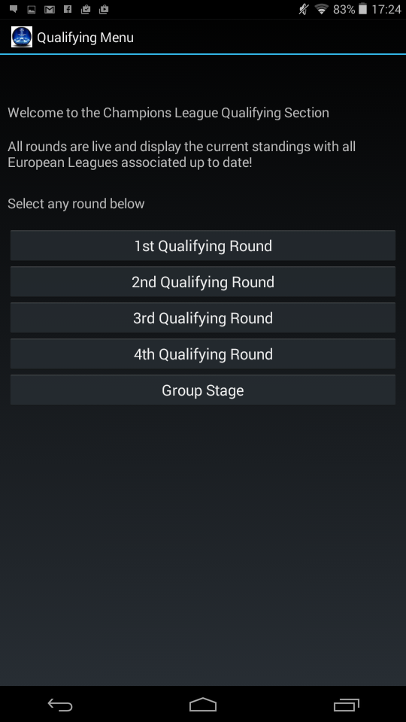

## 1st Qualifying Round

The 1st Qualifying Round provides the user with a live view of the teams entering the 1st round who are all currently top of their respective league.

The Round is then divided in to two, Seeded and UnSeeded.

In this instance 6 teams enter, 3 are seeded and 3 unseeded.

The Seedings are sorted based on each teams ‘Team Ranking’ (Can be cross checked in the Team Ranking Section). The 3 Teams entering with the highest Team Ranking are allocated a seeding spot.

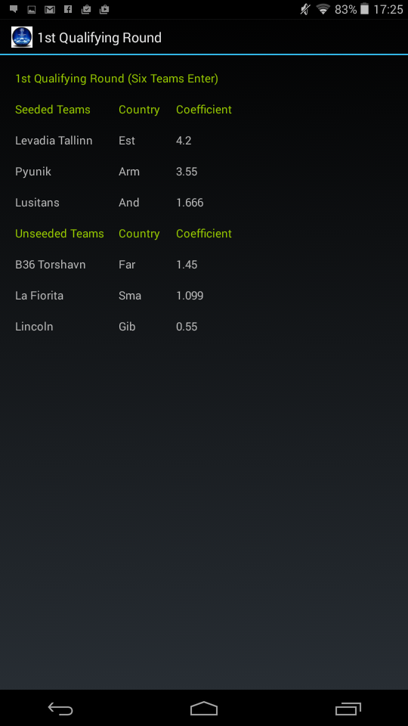

## 2nd Qualifying Round

The 2nd Qualifying Round provides the user with a live view of the teams entering the 2nd round. Each team entering are all currently top of their respective league.

The Round is then divided in to two, Seeded and UnSeeded.

In this instance 34 teams enter the qualifying round (31 new entrants and 3 winners from the 1st round), the top 17 are seeded and bottom 17 unseeded.

**Note: The top 3 ranked teams from the 1st Qualifying Round are included in the second qualifying round because regardless of the victor between teams the winner takes the ranked teams seeding rather than their own. Please see section 3.1 for further explanation.**

The Seedings are sorted based on each teams ‘Team Ranking’ (Can be cross checked in the Team Ranking Section). The 17 Teams entering with the highest Team Ranking are allocated a seeding spot.

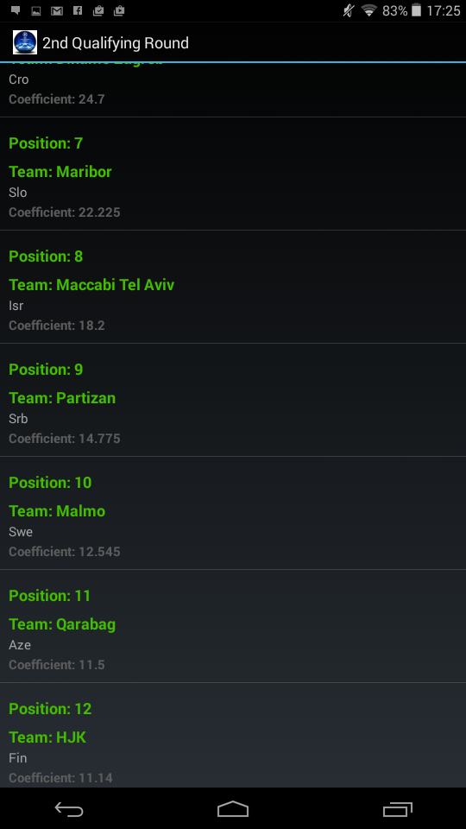

To view all teams in the round you can simply scroll up and down to view all 34 teams. The Position, Team name, Country and Coefficient is provided for each Team entering.

You can also select an individual team. After selecting a team you will be brought to a single screen containing specific information for the team you have selected.

Select Team of choosing:

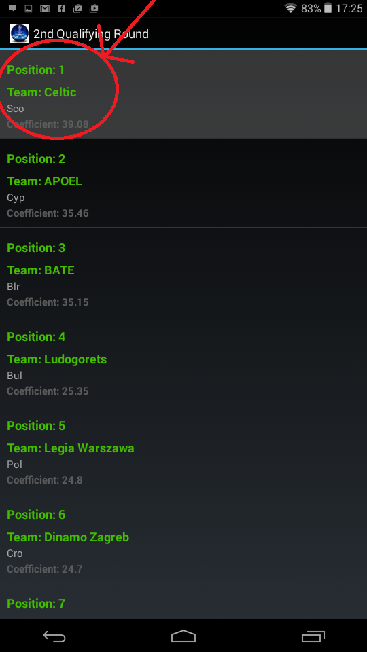

Single Screen for selected Team

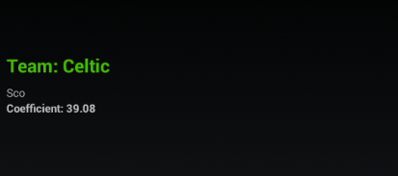

## 3rd Qualifying Round Section

After selecting the 3rd Qualifying Round option from the Qualifying Rounds Menu you will be greeted with a 3rd Round Navigation Menu.

The Menu is comprised of 2 options to which you can select from.

The 3rd Qualifying Round is divided in to 2 sections:

* Round Three Champions Route
* Round Three League Route

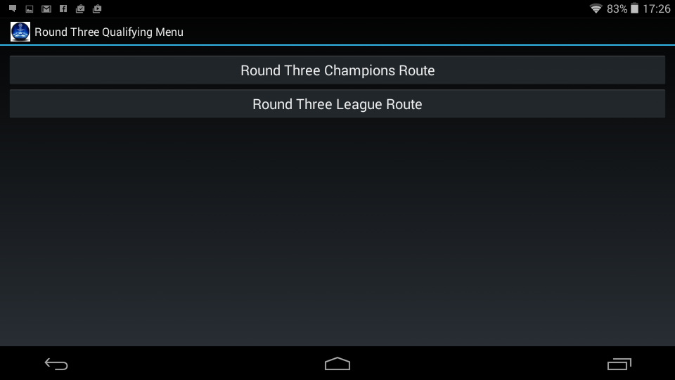

## 3rd Qualifying Round – Champions Route

The Champions Route for the 3rd Qualifying Round provides the user with a live view of the teams entering the Champions Route. Each team entering is currently top of their respective league.

The Round is then divided in to two, Seeded and UnSeeded.

In this instance 20 teams enter the qualifying round (3 new entrants and 20 winners from the 2nd round), the top 10 are seeded and bottom 10 unseeded.

**Note: The top ranked teams from the 2nd Qualifying Round are included in the third qualifying round champions route because regardless of the victor between teams the unseeded winner takes the seeded teams ranking rather than their own. Please see section 3.1 for further explanation.**

The Seedings are sorted based on each teams ‘Team Ranking’ (Can be cross checked in the Team Ranking Section). The 10 Teams entering with the highest Team Ranking are allocated a seeding spot.

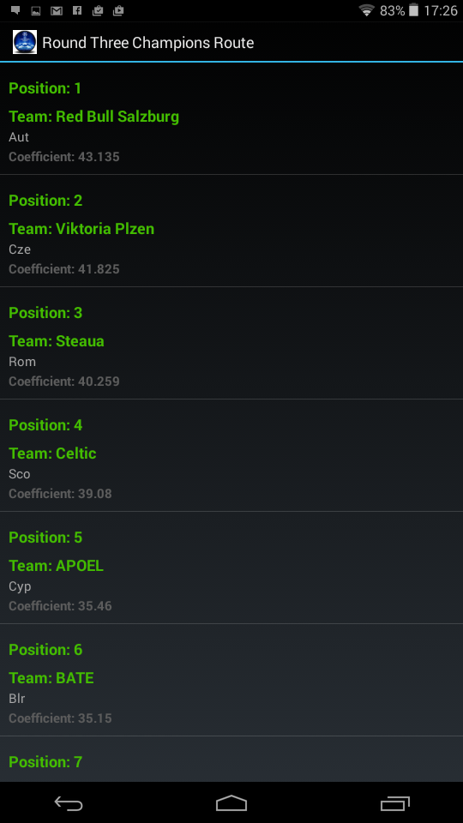

To view all teams in the round you can simply scroll up and down to view all 20 teams.

The Position, Team name, Country and Coefficient is provided for each Team entering.

You can also select an individual team. After selecting a team you will be brought to a single screen containing specific information for the team you have selected.

Select Team of choosing:



Single Screen for selected Team



## 3rd Qualifying Round – League Route

The League Route for the 3rd Qualifying Round provides the user with a live view of the teams entering the League Route. Each team entering has finished runner up in their respective league

The Round is then divided in to two, Seeded and UnSeeded.

In this instance 20 teams enter the qualifying round, the top 10 are seeded and bottom 10 unseeded.

You can browse through all teams in the round via scrolling.

The Seedings are sorted based on each teams ‘Team Ranking’ (Can be cross checked in the Team Ranking Section). The 10 Teams entering with the highest Team Ranking are allocated a seeding spot.

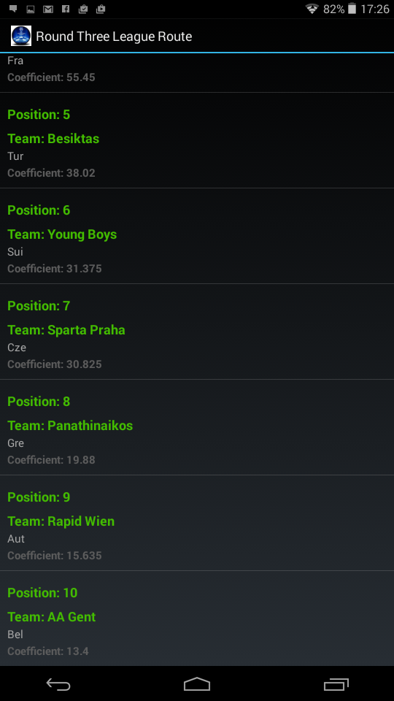

To view all teams in the round you can simply scroll up and down to view all 20 teams.

The Position, Team name, Country and Coefficient is provided for each Team entering.

You can also select an individual team. After selecting a team you will be brought to a single screen containing specific information for the team you have selected.

Select Team of choosing:



Single Screen for selected Team



## 4th Qualifying Round – League Route

The League Route for the 4th Qualifying Round provides the user with a live view of the teams entering the Round. Each team entering has finished runner up in their respective league or 3rd and 4th in some cases (e.g. 4th spot in the English Premier League).

The Round is then divided in to two, Seeded and UnSeeded.

In this instance 20 teams enter the qualifying round (10 new entrants and 10 winners from the 3rd round), the top 10 are seeded and bottom 10 unseeded.

**Note: The top ranked teams from the 3rd Qualifying Round League Route are included in this round however this is purely a prediction. After the 3rd round games finish the seedings are recalculated based on who advanced in that round.**

The Seedings are sorted based on each teams ‘Team Ranking’ (Can be cross checked in the Team Ranking Section). The 10 Teams entering with the highest Team Ranking are allocated a seeding spot.

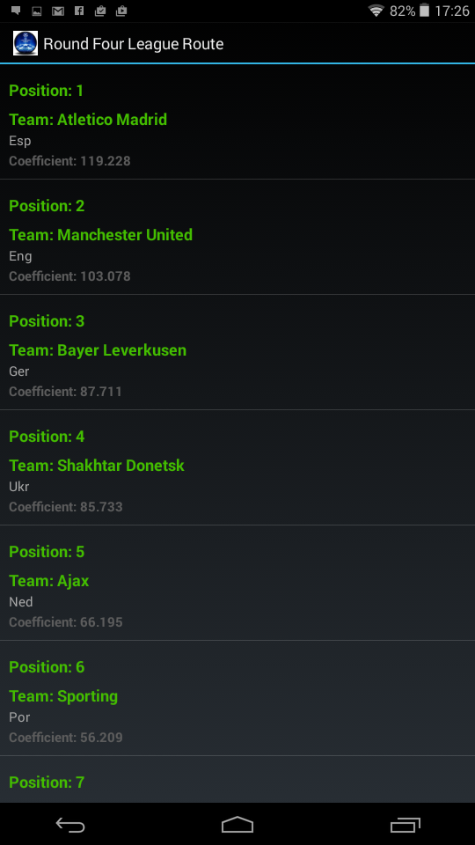

To view all teams in the round you can simply scroll up and down to view all 20 teams.

The Position, Team name, Country and Coefficient is provided for each Team entering.

You can also select an individual team. After selecting a team you will be brought to a single screen containing specific information for the team you have selected.

Select Team of choosing:



Single Screen for selected Team



## Group Stages

The Group Stage section provides a live view of the teams that will enter the Champions League Group Stage. Each Team entering has qualified for the group stage either by winning, finishing runner up in their respective league, or qualifying through the Qualifying Round League Route and Champions Route.

The Group Stage is divided in to four sections:

* Pot 1 – 8 Teams
* Pot 2 – 8 Teams
* Pot 3 – 8 Teams
* Pot 4 – 8 Teams

In this instance 32 teams enter the Group Stage, they have entered through the following paths:

* 5 Winners from the Champions Route
* 5 Winners from the League Route
* 12 Champions of each league with their Country Ranked 1-12 (See Access List*)
* 6 Runners Up of each league with their Country Ranked 1-6*
* 3 third placed teams of each league with their Country Ranked 1-3*

**Note: The top 3 ranked teams from the 1st Qualifying Round are included in the second qualifying round because regardless of the victor between teams the winner takes the ranked teams seeding rather than their own. Please see section 3.1 for further explanation.**

The Seedings are sorted based on each teams ‘Team Ranking’ (Can be cross checked in the Team Ranking Section). The 32 teams entering are allocated to each pot based on their Team Ranking. For example, the 8 teams with the highest ranking of the 32 enter Pot One with the next 8 highest entering Pot 2 and so on.

To view all teams in the Group Stages you can simply scroll up and down to view all 32 teams.

The Position, Team name, Country and Coefficient is provided for each Team entering.

The following teams enter the following pots based on their position:

Teams with the following “Position” will be allocated to each respective Pot for the group stage Draw:

“Position” **1-8** – **Pot One**

“Position” **9-16** – **Pot Two**

“Position” **17-24** – **Pot Three**

“Position” **25-32** – **Pot Four**

You can also select an individual team. After selecting a team you will be brought to a single screen containing specific information for the team you have selected.

Select Team of choosing:



Single Screen for selected Team



## Team Ranking Section

The Team Ranking section can be accessed by selecting the ‘Team Ranking’ option from the Main Menu Section.

The Team Ranking section contains the full set of UEFA Rankings of 508 teams.

The Team Rankings are sorted by the Coefficient* of each team, in descending order of the team with the highest Coefficient.

The ‘base’ Ranking of Countries is also included within the Team Ranking section. The purpose of the ‘base’ ranking is for Teams of the Country in question that don’t have a Team Ranking. For qualification purposes a team with no ranking takes the Base Ranking of their country, this is why it is included.

Each Team is labeled with their Position, Team Name, Country and Coefficient*

*Team Ranking

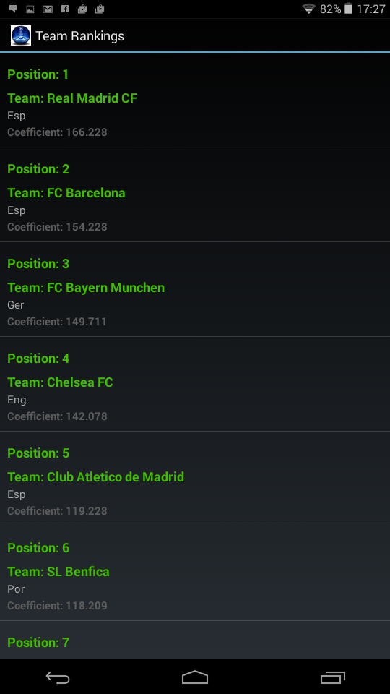 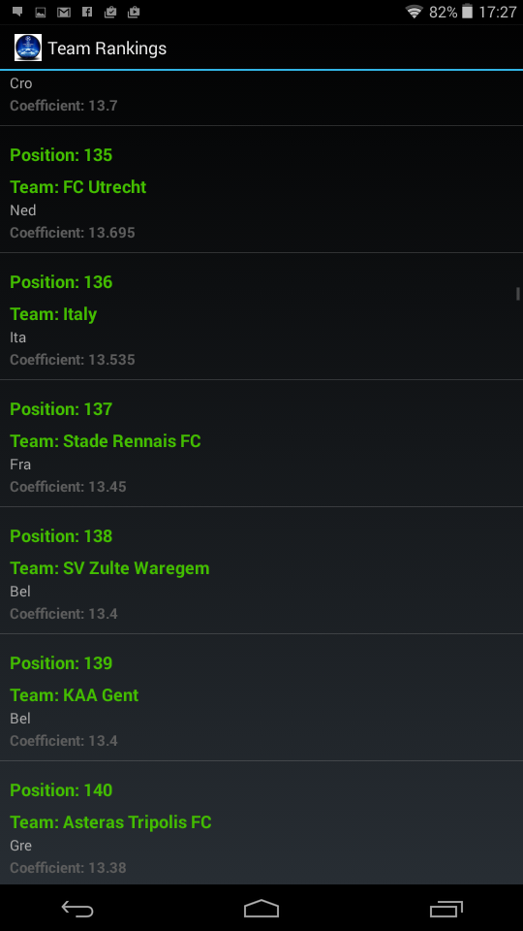

You can also select an individual team from the Full Team Ranking. After selecting a team you will be brought to a single screen containing specific information for the team you have selected.

Select Team of choosing:



Single Screen for selected Team



## Country Ranking Section

The Country Ranking section can be accessed by selecting the ‘Country Ranking’ option from the Main Menu Section.

The Country Ranking section contains all

The Country are sorted by the Coefficient* of each country, in descending order of the country with the highest Coefficient.

Country Team is labeled with their Position, Country Name and Coefficient*

*Country Ranking

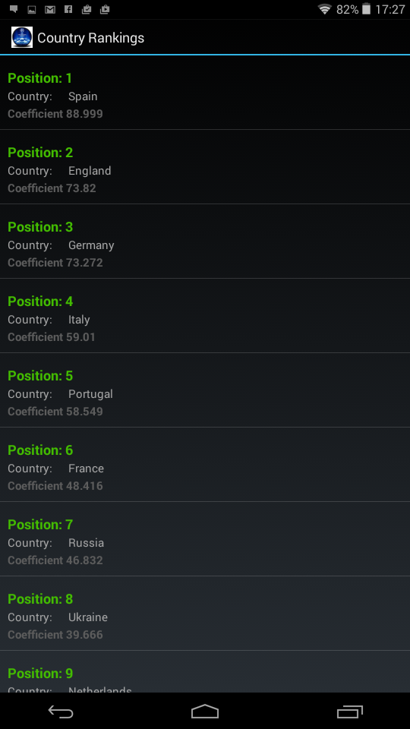 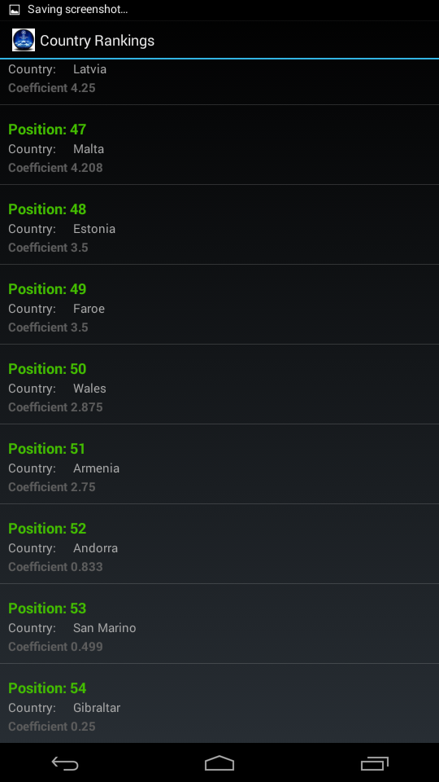

You can also select a country from the full Country Rankings. After selecting a country you will be brought to a single screen containing specific information for the country you have selected.

Select Country of choosing:

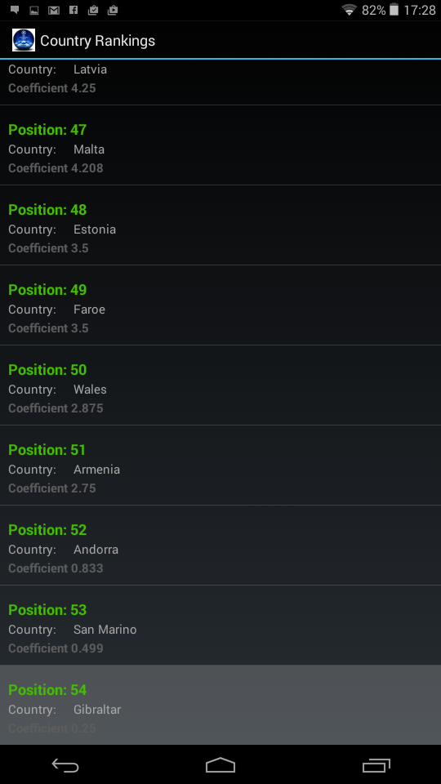

Single Screen for selected Team

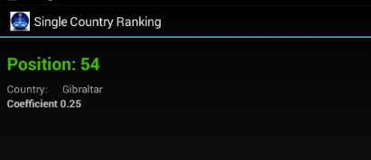

## Additional Sections

### About Section

The About section can be accessed by selecting the ‘About’ option from the Main Menu Section. To return to the menu simply select the standard Back Button

### Help Section

The Help section can be accessed by selecting the ‘Help’ option from the Main Menu Section. To return to the menu simply select the standard Back Button

# Troubleshooting

The following table lists some common issues and their resolutions:

|  |  |  |
| --- | --- | --- |
| Symptoms | Reasons | Resolutions |
| The Mobile Apps Core Functionality does not load or throw errors | Not connected to WIFI or Mobile Network. Although Connected you may not have Internet data incoming and outgoing at present. | Verify WIFI is enabled and connected. Also check if other internet based application are running correctly. |
| Application won’t open or freezes | System CPU and Ram may be used up | Check current CPU and RAM usage and close down other application if necessary and try again. |